Week 3 – Group Assignment
Instructions
Design a graph testing model for your project application.
- Identify a portion of your project that can be tested with graph-based testing.
- Based on the identified components, create a graph model. The graph model should capture the key decision points, branches, and dependencies of the graph-based components.
- Select a testing coverage criteria. Make sure to have a rationale for the selected criteria.
- Based on the selected criteria, generate a set of test cases.
- Execute the test cases.
- Document and report any identified issues or defects related to the graph-based components. Provide clear steps to reproduce the issues and include any relevant details or observations from the graph-based testing process.

1. Selected Portion of the Application
The portion tested is the “Place Order” feature of the pizza-ordering module.
This flow begins when a user clicks Order after selecting pizza(s) and ends when the order reaches the Delivered status.
It involves both authenticated and unauthenticated user paths.

2. Graph Model
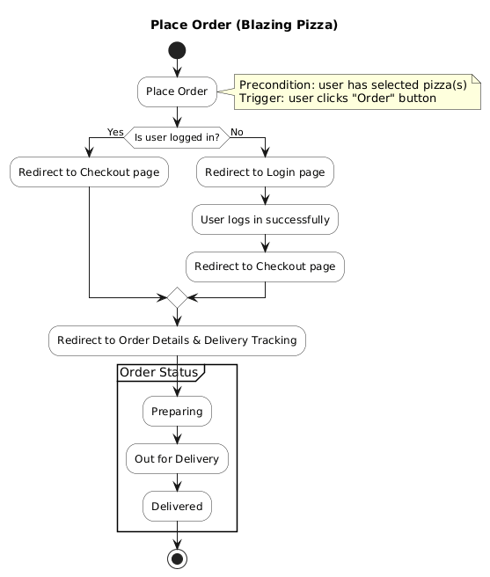
3- Selected Coverage Criteria
Criterion: All Path Coverage
Rationale:
We chose All Path Coverage because the “Place Order” process is straight-forward and linear, with only one main decision point; checking whether the user is logged in or not. This results in just two possible paths through the flow: one for logged-in users and one for users who must log in before continuing. Since the graph doesn’t contain any loops or repeating branches, it’s entirely possible to test every path from start to finish without unnecessary complexity.
Using All Path Coverage ensures that every possible user journey in this scenario is verified, giving us high confidence that both authentication and order handling behaviors work as expected.
4- Generated Paths and Test Cases
Generated Paths:
Path | Description | Steps | Expected Results
A | Logged-in User | - Place Order  - Is user logged-in? Yes  - Redirect to Checkout page  - Redirect to Order Details and Delivery Tracking page  - Order Status: Preparing  - Order Status: Out for Delivery  - Order Status: Delivered | When the user clicks the “Order” button, they are redirected to the Checkout page to enter their address. After submitting this information, the system redirects them to the Order Details and Delivery Tracking page, where they can view and track the status of their order in real time.
B | Not Logged-in User | - Place Order  - Is user logged-in? No  - Redirect to Login page  - User logs in successfully  - Redirect to Checkout page  - Redirect to Order Details and Delivery Tracking page  - Order Status: Preparing  - Order Status: Out for Delivery  - Order Status: Delivered | When the user clicks the “Order” button, they are redirected to the Login page. After logging in with valid credentials, the system redirects them to the Checkout page to enter their address. Once the information is submitted, the user is taken to the Order Details and Delivery Tracking page, where they can view and monitor the progress of their order.

Test Cases:
ID | Preconditions | Steps | Expected
TC-A1 | User authenticated | Click Order | Navigates to /checkout
TC-A2 | At checkout | Place order | Opens /myorders/{id} showing Order Details and Order Status = Preparing
TC-A3 | Order Status = Preparing | Wait/status | Order Status = Out for Delivery
TC-A4 | Order Status = Out for Delivery | Wait/status | Order Status = Delivered
TC-B1 | User not authenticated | Click Order | Redirects to /account/login
TC-B2 | On login | Submit valid credentials | Navigates to /checkout
TC-B3 | From checkout | Place order | Opens /myorders/{id} showing Order Details and Order Status = Preparing
TC-B4 | Order Status = Preparing | Wait/status | Order Status = Out for Delivery
TC-B5 | Order Status = Out for Delivery | Wait/status | Order Status = Delivered

Code Behavior | Test Case IDs | Description
Logged-in user path (precondition: user is already authenticated via EnsureLoggedInAsync()) | TC-A1 TC-A4 | The “Yes” branch of your flowchart. The test Logged_In_User_ConfigurePizza_OrderDetails_And_DeliveryTracking() covers this.
Not-logged-in user path | TC-B1 TC-B5 | The “No” branch of your flowchart. The test Not_Logged_In_User_ConfigurePizza_OrderDetails_And_DeliveryTracking() covers this.

5- Identified Defects and Observations
1. Login Page - Generic Error Message for Unauthorized Users
- Issue: When an unauthorized user attempts to log in, the system displays a generic “Login failed” message.
- Observation: The error message does not clearly indicate whether the issue is due to invalid credentials, or an unauthorized/unverified account.
- Expected Behavior: Display context-specific messages (e.g. “Incorrect email or password,” “Account not verified,” or “User not found”).
- Steps to Reproduce:
  - Navigate to /account/login.
  - Enter invalid credentials or a non-existent email.
  - Observe the generic error message.

2. Login Page - Missing Navigation for Non-Existent Users
- Issue: When a user who is not registered tries to log in, the system does not offer a way to register directly.
- Observation: The user remains on the login screen without guidance.
- Expected Behavior: Redirect non-existent users to the registration page (/account/register) with a message like “Account not found. Would you like to register?”
- Steps to Reproduce:
  - Attempt to log in using an unregistered email.
  - Observe that the app does not navigate to registration.

3. Missing Guest Checkout Option
- Issue: Users cannot proceed to checkout without logging in.
- Observation: This limits user accessibility, especially for first-time or occasional users.
- Expected Behavior: Allow a “Guest Checkout” option that requires only an email and address, skipping full authentication.
- Steps to Reproduce:
  - Add a pizza to the cart.
  - Click “Order” without logging in.
  - Observe that there is no “Continue as Guest” option.

4. Login Page - Unverified Email Not Handled Gracefully
- Issue: If a user attempts to log in before verifying their email, no clear message is shown.
- Observation: The system either fails silently or displays a generic login error.
- Expected Behavior: Display a message like “Your email address has not been verified. Please check your inbox to complete verification.”
- Steps to Reproduce:
  - Register a new account but do not verify the email.
  - Attempt to log in.
  - Observe the lack of specific feedback.

5. Checkout Page - Missing Address Validation
- Issue: The address fields on the checkout page do not validate inputs for accuracy.
- Observation: The system allows incomplete or invalid addresses to be submitted.
- Expected Behavior: Integrate an address validation API or package (e.g., Google Maps API, USPS Address Validator) to ensure valid and deliverable addresses.
- Steps to Reproduce:
  - Proceed to /checkout.
  - Enter an incomplete or invalid address (e.g. “123”).
  - Attempt to place the order.
  - Observe that no validation error is displayed.

